NEWRELIC

Link: [API Keys < New Relic](https://one.newrelic.com/admin-portal/api-keys/home?account=7291193&state=1fb9cb6f-2be6-f786-0aad-07e692e6925f)

Email: [289250@ust.com](mailto:289250@ust.com)

Password: Observability@123

Q. What is New Relic?

* **New Relic** is an **Application Performance Monitoring (APM)** and **observability platform**.  
  It helps you **monitor, analyze, and troubleshoot** applications and infrastructure in real-time.
* A tool to **watch how your app and systems are working** — it shows if your app is **slow, has errors, or is down**, and where the problem is.

Q. Why newrelic is used?

* See if your app is **slow or has errors**
* Find **where** the problem is (code, server, or database)
* Get **alerts** when something goes wrong
* Keep everything (app, server, logs) in **one dashboard**

So simply — **it helps developers and teams make sure their apps run fast, work well, and don’t break.**

**Used -** Monitoring applications, infrastructure, logs, and business performance.

Q. What is path point in newrelic?

**Pathpoint** in New Relic shows the **steps a user takes in your app** — like a map of the user’s journey — and tells you **how each step is performing**.

* For example, if your app is an online shopping site, Pathpoint can show:  
  🛒 Home → Search → Add to Cart → Payment → Order Success
* Each step (stage) shows live data — how many users reach it, how long it takes, and where errors happen.

Q. Why pathpoint is used?

* It helps teams **see how technical issues affect the business.**
* If the “Payment” step is slow, Pathpoint will highlight it in red.
* This tells you that “users are stuck while paying,” so you can fix that part quickly.
* **It connects app performance with business impact** (like drop in orders or revenue).

Q. How newrelic is diff from Dynatrace, splunk and Grafana?

* Newrelic: All in 1 tool to monitor app, server, logs, and user flow. Checking app performance + user experience
* Dynatrace: A smart monitoring tool that uses AI to find issues automatically. Best for For large systems where you want automatic problem detection. Example: If one microservice in a bank’s system crashes, Dynatrace’s AI will find it and tell you the root cause.
* Splunk: Mainly used to collect and search logs from many sources. Best for For analyzing logs and checking security issues. Example: If your website fails, Splunk can search through all logs to find the exact error message or hacker activity.
* Grafana: A dashboard tool to display metrics and graphs from other tools. Example: Grafana can show CPU usage or app traffic from Prometheus or New Relic in colorful charts.
* **New Relic & Dynatrace** → watch your **apps and systems**.

Q. Is traces and pathpoint are similar?

**Traces**

* Automatic.. User clicks “Pay Now.”  
  Trace shows:  
  Frontend → Order Service → Payment Service → Database
* Show the **technical path** of a single request inside your app.
* Help developers see **which service or API is slow**.
* It’s more **backend-focused**.
* **Example:**  
  When a user clicks “Pay Now,” the trace shows:  
  frontend → order-service → payment-service → database  
  You can see exactly **where the delay happens**.

**Pathpoint:**

* **A Pathpoint shows the manual steps a user takes in your app (like going from one page to another).**
* Shows the **user’s full journey** in the app — like a business flow.
* Helps you see **which step users struggle with** and how it affects your **business goals**.
* It’s more **user and business-focused**.
* **Example:**  
  User flow:  
  Home → Search → Add to Cart → Payment → Success  
  If the *Payment* step turns red, Pathpoint shows that many users can’t complete checkout.
* • **Traces = “Where did this request go?”**
* • **Pathpoint = “Where did the user go?”**

28/10/25

TASK:

Merin: I created a new key and added it in the otelconfig file, now data is coming to newrelic.Please start working on the pathpoint

Q. where u can see the services on tha application?

* APM and Services on left side -> U can see the services
* If u click on a particular service u can see the **response time, Apdex score, Throughput, errors.**

Q. How to set up path pointing?

* Apps on left side -> search path pointing -> click -> No flows yet u can see.
* Screenshot:

* Create a new flow:

* Create:

* Added level and added step and gave name as frontend and added signal:

* Added level 2 -> step add -> product catalog -> add signal -> select the service product catalog and save itA screenshot of a computer

  AI-generated content may be incorrect.
* Do same for payment, Shipping, Recommendation  
  A screenshot of a computer

  AI-generated content may be incorrect.
* Now you’re halfway done setting up your **Pathpoint user journey**.
* Let’s make it **actually show useful insights** like success rate, latency, and errors
* I created a different pathpoint:  
  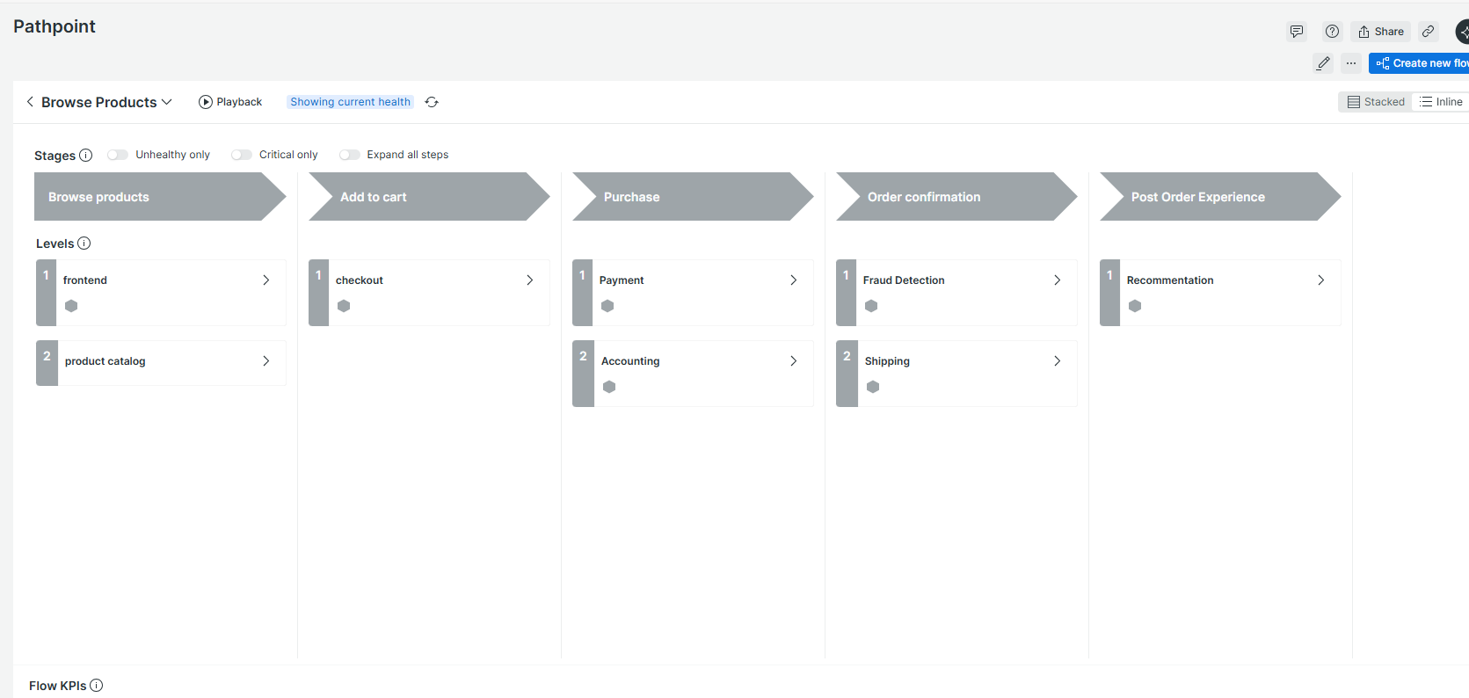
* To add stage:  
  A screenshot of a computer

  AI-generated content may be incorrect.
* Add **Flow KPIs: Scroll to the bottom of your Pathpoint page — you’ll see “Flow KPIs” → click ➕ Create new KPI**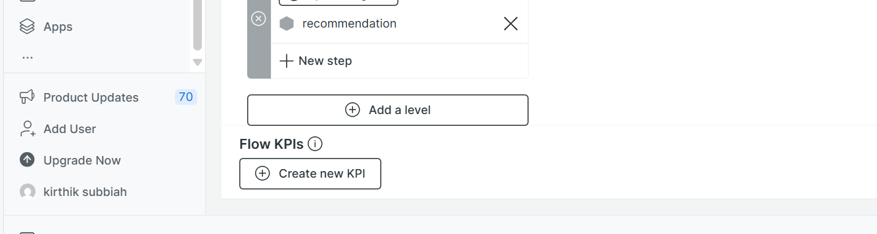
* Create new kpi:  
  **KPI name:** Total requests  
  FROM Span

SELECT count(*) AS 'Total Requests'

SINCE 7 days ago

* **KPI name:** Throughput(App-level)  
  FROM Span

SELECT rate(count(*), 1 minute) AS 'Requests per minute'

SINCE 5 minutes ago

* **KPI name:** Error Rate(App level)  
  FROM Span

SELECT percentage(count(*), WHERE status.code != 1) AS 'Error Rate (%)'

SINCE 5 minutes ago

* **KPI name:** Overall latency  
  FROM Span

SELECT average(duration.ms) AS 'Overall Latency (ms)'

SINCE 5 minutes ago

* Screenshot:  
  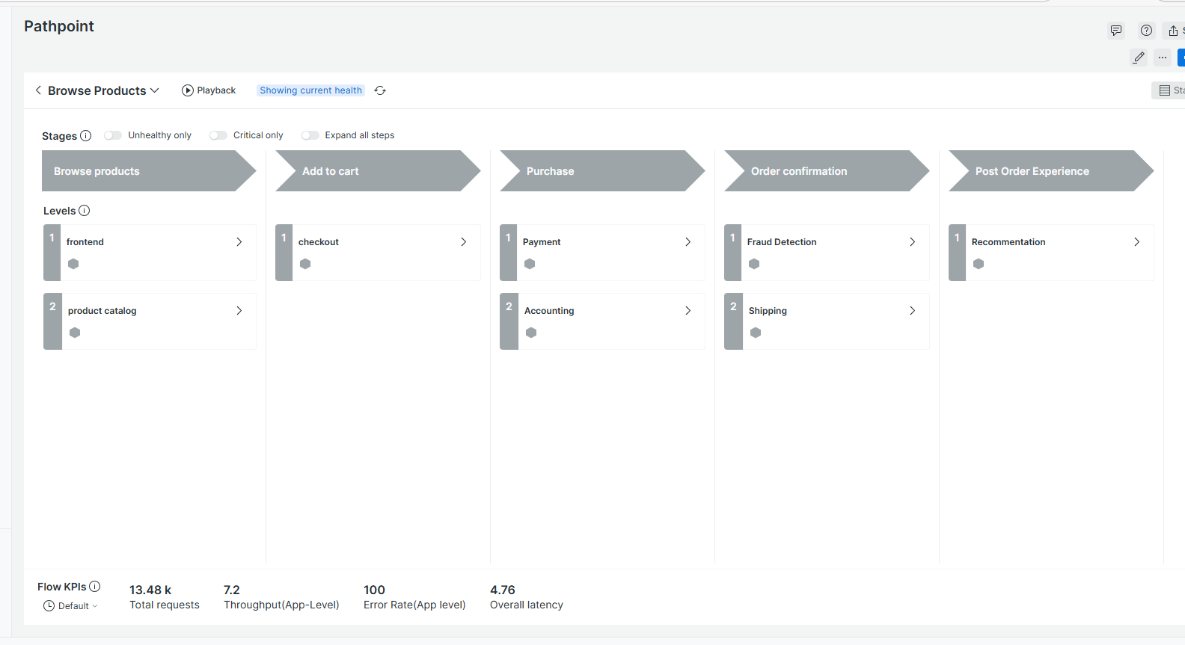

Q. How to Give colour to ur pathpoint?

* Click playback:  
  A screenshot of a computer

  AI-generated content may be incorrect.

Q. How to see the signals that u used also in bottom?

Click on stacked.

Q. How to create dashboard in newrelic?

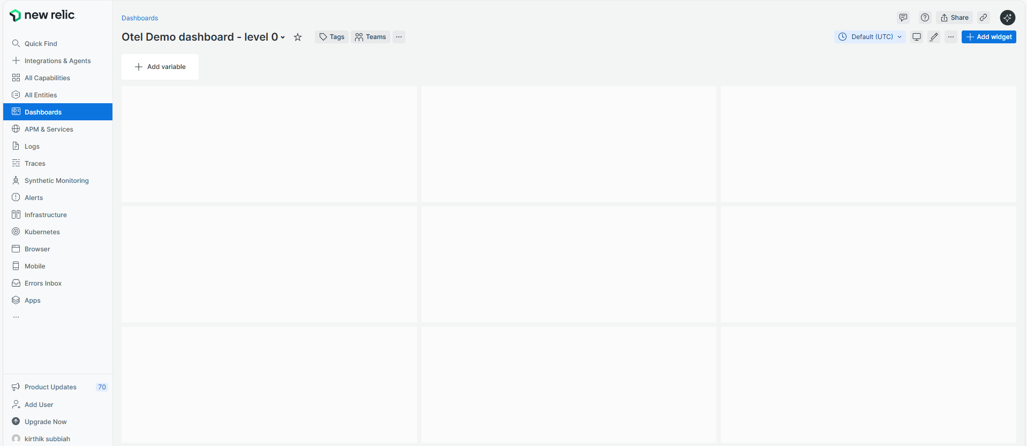

Q. How to add panels in ur dashboard?

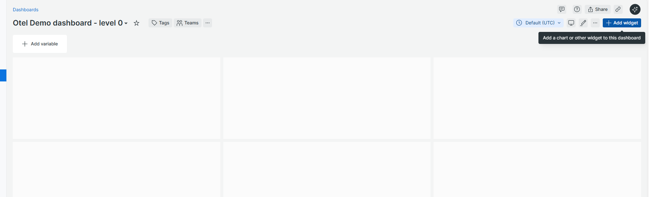

Type ur querry here.

Q. How to check what data types your app is sending?

* SHOW EVENT TYPES (Type this querry)  
  A screenshot of a computer

  AI-generated content may be incorrect.
* U are sending only **Span**, **Metric**, and **Log** data , No transaction data.

Q. How to check how much span and errors?

* FROM Span

SELECT count(*), count(error)

LIMIT 100

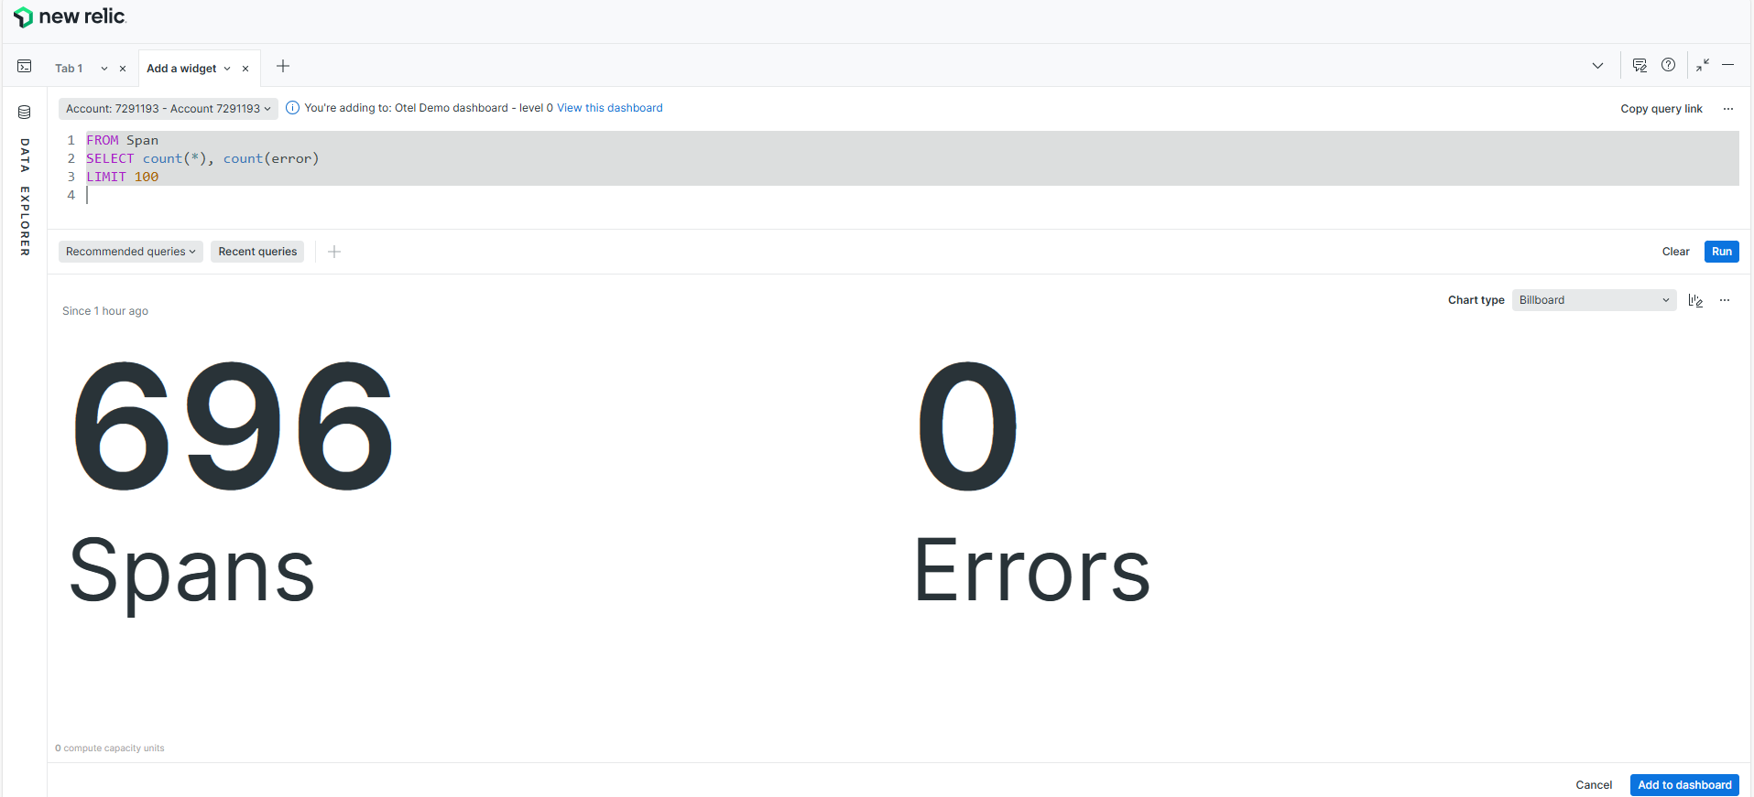

Q. Creating Panels:

1. Error Slo Compliance(%):

* FROM Span

SELECT 100 - percentage(count(*), WHERE error = true) AS 'Error SLO Compliance (%)'  
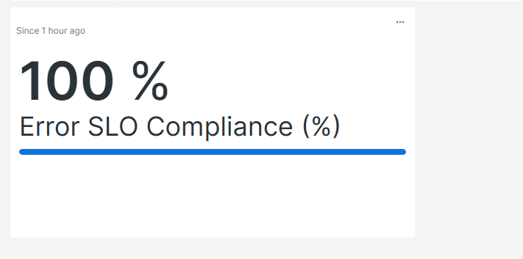

* If there are **0 errors**, this becomes 0%.
* Then you subtract from 100 → 100 - 0 = 100%.
* So your application is Compliant with the error SLO — no errors detected in the selected time window.”

2. Application error rate:

FROM Span

SELECT percentage(count(*), WHERE error = true) AS 'Error Rate (%)'

3. latency slo compliance:

FROM Span

SELECT 100 - percentage(count(*), WHERE duration.ms > 400) AS 'Latency SLO Compliance (%)'

4. 95th percentile response time for app:

FROM Span

SELECT percentile(duration.ms, 95) AS 'Response Time (ms) - 95th Percentile'

5. SLO set and threshold set:

Add widget -> Text images -> paste this below content separately:

* ### SLOs set:

- **Error rate:** critical < **99.9 %**, warning < **99.95 %**

- **Latency:** critical < **90 %**, warning < **95 %**

* ### Thresholds set:

- **Error rate:** warning **0.05 %**, critical **0.1 %**

- **Latency:** warning **400 ms**, critical **500 ms**

6. Table with service name, error %, req/s, Resp Time (ms) (95%).

* FROM Span

SELECT

percentage(count(*), WHERE error = true) AS 'Error (%)',

rate(count(*), 1 second) AS 'Req/s',

percentile(duration.ms, 95) AS 'Resp Time (ms)'

FACET service.name

ORDER BY 'Error (%)' DESC

LIMIT 100

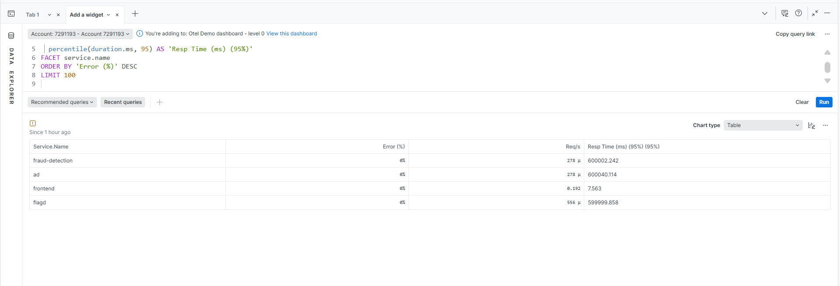

* Only these services are active now.. That’s y only 4 services have shown.
* So I checked the unique service names using a querry:

FROM Span

SELECT uniqueCount(service.name)

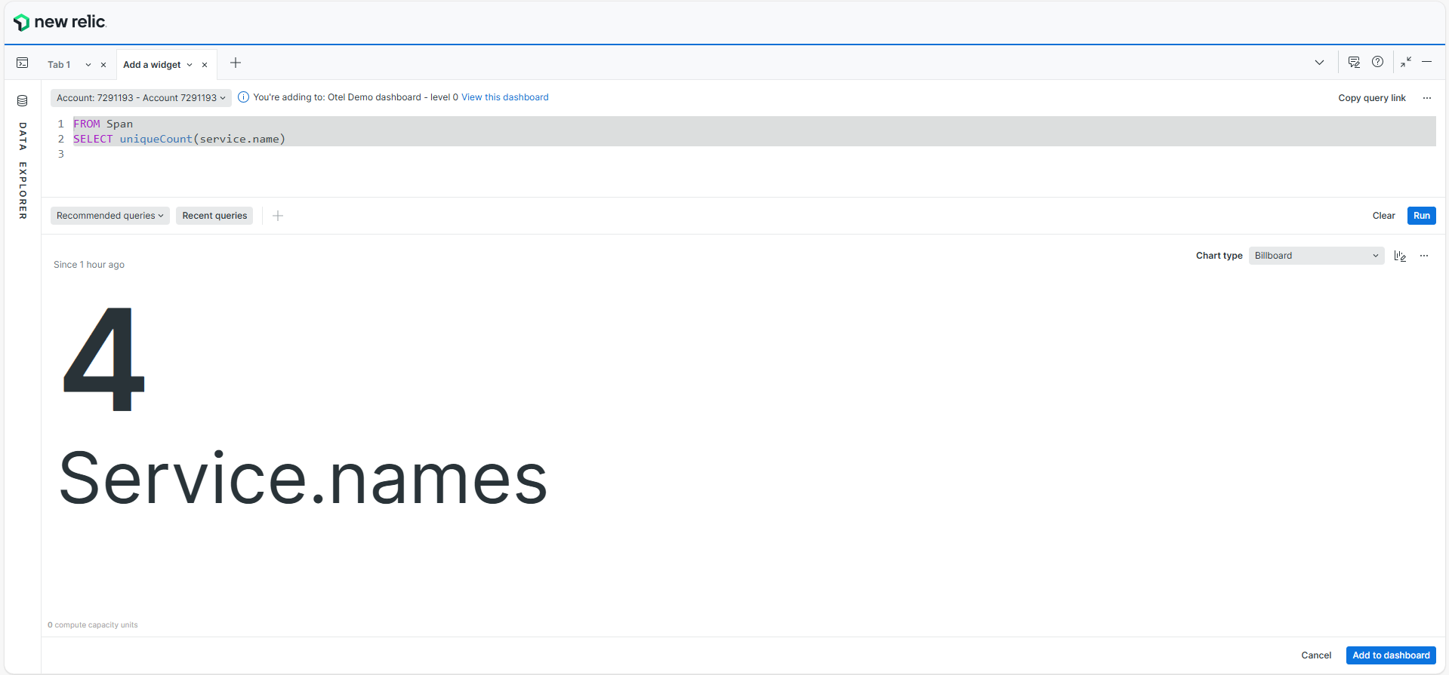

Q. For renaming the page:

Edit -> rename page : rename it

Q. Aim to create a similar page like this on level 0:  
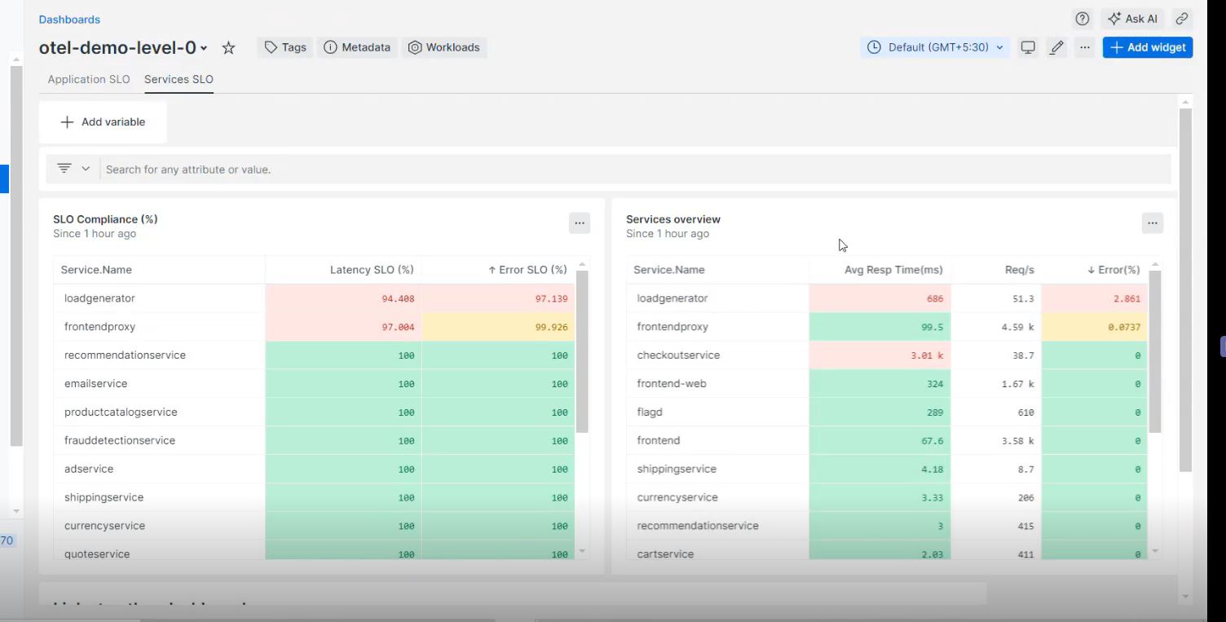

Steps:

1. Panel 1: Service SLO Compliance Table

FROM Span

SELECT

(100 - percentage(count(*), WHERE duration.ms > 1000)) AS 'Latency SLO (%)',

(100 - percentage(count(*), WHERE http.status_code >= 400)) AS 'Error SLO (%)'

FACET service.name

ORDER BY 'Latency SLO (%)' ASC

LIMIT 100  
  
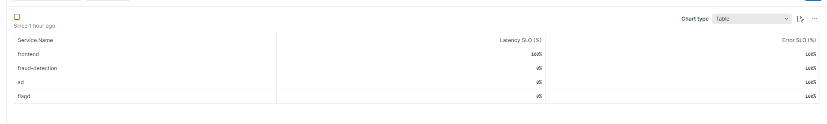

2. Panel 2: Services Overview  
  
FROM Span

SELECT

average(duration.ms) AS 'Avg Resp Time (ms)',

rate(count(*), 1 second) AS 'Req/s',

percentage(count(*), WHERE error = true) AS 'Error (%)'

FACET service.name

ORDER BY 'Error (%)' DESC

1. Panel 3 : Overall SLO health:  
     
   FROM Span

SELECT

percentage(count(*), WHERE duration.ms < 500) AS 'Latency Compliance (%)',

100 - percentage(count(*), WHERE error = true) AS 'Error Compliance (%)'

Q. Screenshots of level 0 created now:  
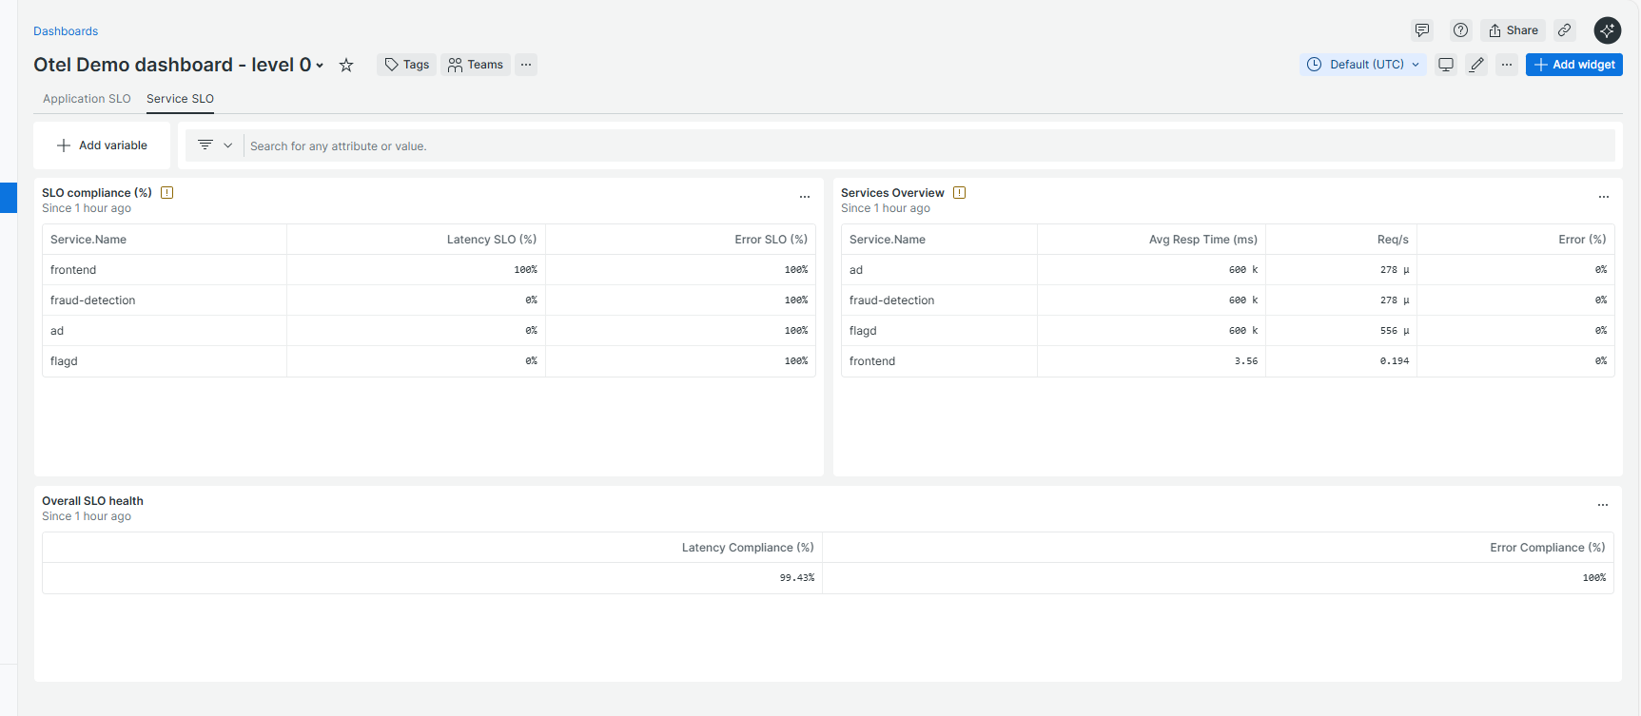

Q. Aim to create a level 1 dashboard in newrelic similar to below screenshot:  
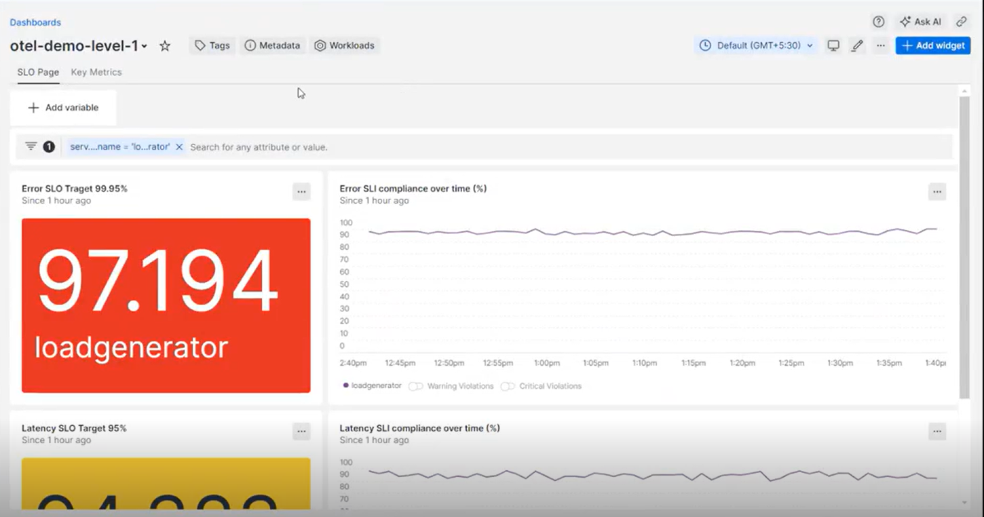

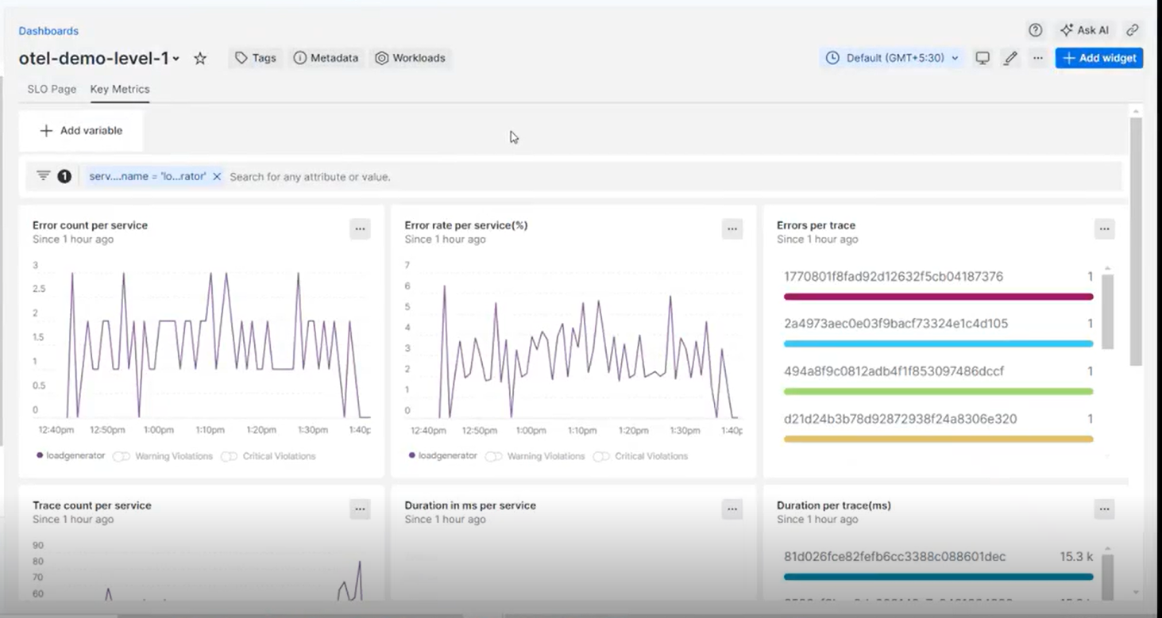

I need to create a level 1 dashboard with these panels and level 1 dashboard should pick up the service I am clicking from level 0 and show the details of that particular service.  
  
required things:

1. Create a markdown to show the service name(it should pick up the service name I am clicking on level 0)
2. So u should create a variable .. instead of service name .. so u can access the service details without hardcoding.
3. Create 2 pages :
   1. SLO page
   2. Key metrics
4. Panels required in SLO page:
   1. Error SLO target 99.95%
   2. Error SLI compliance overtime(%)
   3. Latency SLO target 95%
   4. Latency SLI compliance overtime(%)
5. Panels required in key metrics page:
   1. Error count per service
   2. Error rate per service
   3. Error per trace
   4. Trace count per service
   5. Duration in ms per service
   6. Duration per trace(ms)

Steps:

1. Create a variable:
   1. First change the time range to last 6 months.
   2. Use querry:

FROM Span

SELECT uniques(service.name)

WHERE service.name IS NOT NULL

* 1. Turn off the use time picker (because the data was missing -> only 4 services were showing.. when I turned off I can see many services)

Screenshots:

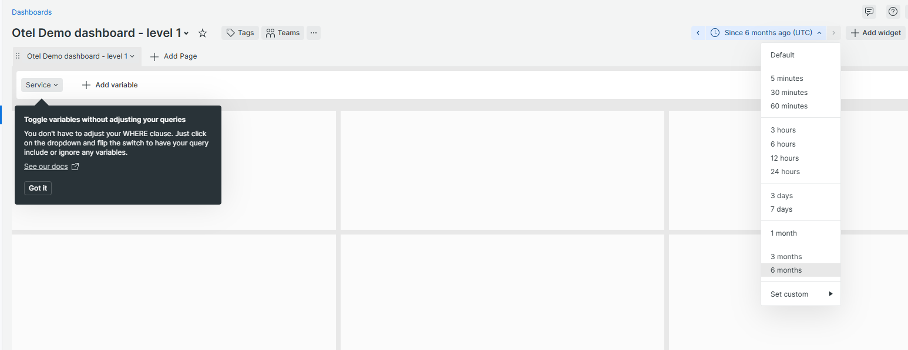

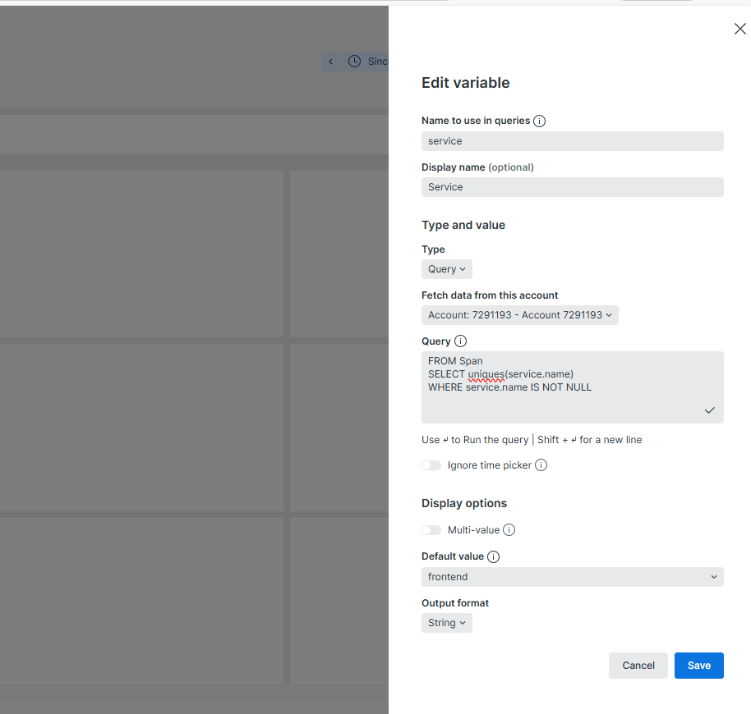

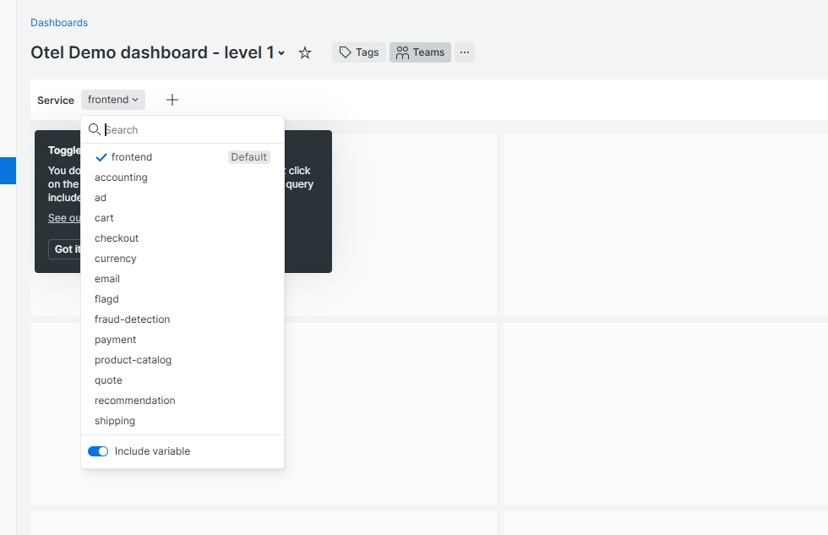

1. Rename the page:

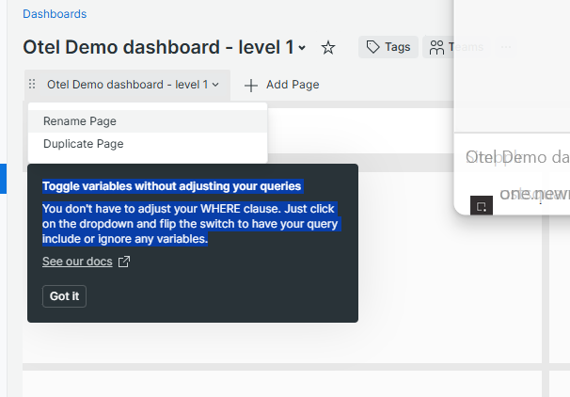

1. How to include variables I have created in querries:
   1. Documentation: [Template variables: dynamically filter dashboards | New Relic Documentation](https://docs.newrelic.com/docs/query-your-data/explore-query-data/dashboards/dashboard-template-variables/#include-variable)
2. Panels creation using variable:
   1. Error SLO %  
        
      FROM Span

SELECT percentage(count(*), WHERE error = true) AS 'Error SLO (%)'

WHERE service.name IN ({{service}})   
FACET service.name

* FACET service.name : This will show the service name also.

Screenshot:

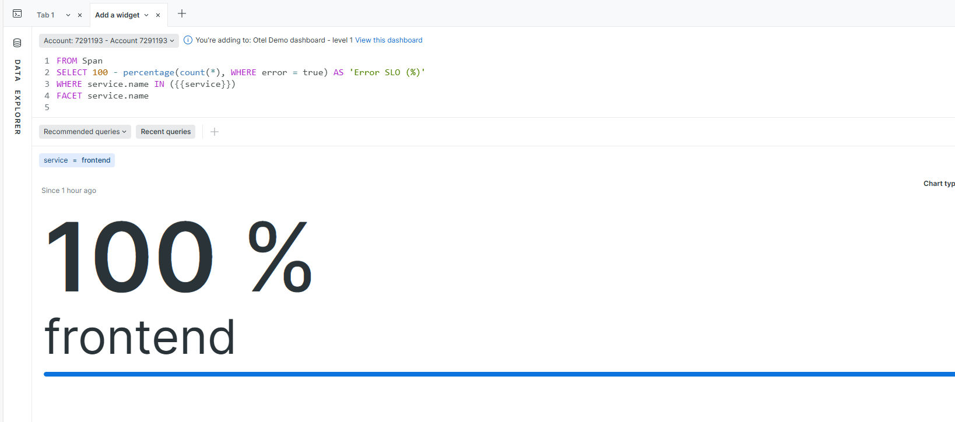

I got 0% after running the same querry idk y?  
FROM Span

SELECT trace.id, name, http.status_code, duration.ms, service.name

WHERE service.name IN ({{service}})

LIMIT 100

**Correct querry:**FROM Span

SELECT percentage(count(*), WHERE http.status_code >= 500) AS 'Error SLO (%)'

WHERE service.name IN ({{service}})  
FACET service.name

* 1. “Success Rate / Error SLI compliance overtime”

FROM Span

SELECT

100 * filter(count(*), WHERE error IS NULL OR error = false) / count(*) AS 'Success Rate (%)'

WHERE service.name IN ({{service}})

TIMESERIES AUTO

FACET service.name

* 1. Latency SLO:

FROM Span

SELECT percentage(count(*), WHERE duration.ms <= 500) AS 'Latency SLO (%)'

WHERE service.name IN ({{service}})

* 1. Latency SLI compliance over time:

FROM Span

SELECT 100 * filter(count(*), WHERE duration.ms <= 500) / count(*) AS 'Latency SLI (%)'

WHERE service.name IN ({{service}})

TIMESERIES AUTO

1. Key metrics page:
   1. Error count per service(Line)

SELECT count(*) AS 'Error Count'

WHERE http.status_code >= 500 AND service.name IN ({{service}})

FACET service.name

TIMESERIES AUTO

* 1. Error rate per service: Line

FROM Span

SELECT

100 * filter(count(*), WHERE http.status_code >= 500) / count(*) AS 'Error Rate (%)'

WHERE service.name IN ({{service}})

FROM Span

SELECT

100 * filter(count(*), WHERE http.status_code >= 500) / count(*) AS 'Error Rate (%)'

WHERE service.name IN ({{service}})

TIMESERIES AUTO

* 1. Error per trace: Bar

FROM Span

SELECT

filter(count(*), WHERE http.status_code >= 500) AS 'Error Spans',

count(*) AS 'Total Spans',

100 * filter(count(*), WHERE http.status_code >= 500) / count(*) AS 'Error Rate (%)'

WHERE service.name IN ({{service}})

FACET trace.id

LIMIT 100

* 1. Trace count per service:

FROM Span

SELECT uniqueCount(trace.id) AS 'Trace Count'

WHERE service.name IN ({{service}})

FACET service.name

* 1. Duration in ms Per Service (using variable):

FROM Span

SELECT average(duration.ms) AS 'Avg Duration (ms)'

WHERE service.name IN ({{service}})

* 1. Duration Per Trace (ms) (using variable):

FROM Span

SELECT average(duration.ms) AS 'Avg Duration (ms)'

WHERE service.name IN ({{service}})

FACET trace.id

LIMIT 100

SCREENSHOTS OF LEVEL 1:

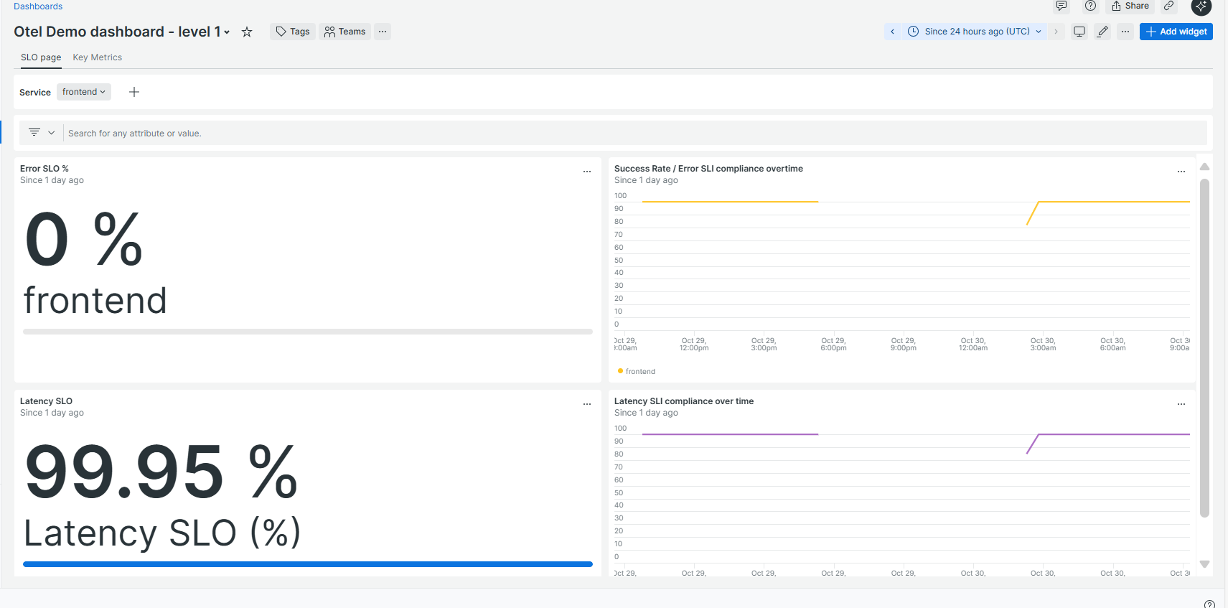

Markdown:

Q. Aim: Implement drill down feature on level 0..when I click the service name on the panel it should show the details of that service in level 1..

Steps:

1. Edit the panel where u want to do drilldown
2. Select **Facet Linking**
3. Filter a related dashboard
4. Select the level 1 dashboard

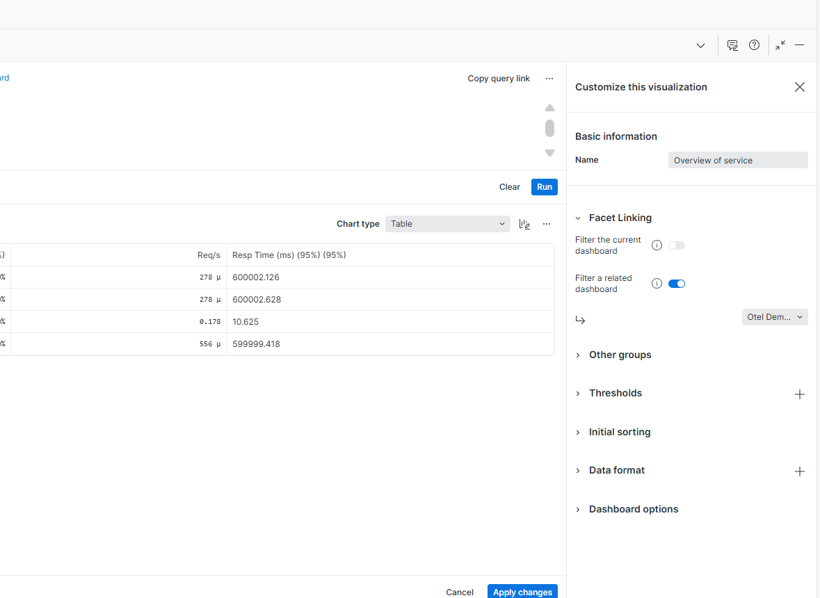

Q. ISSUE:

Now it is redirecting from level 0 panel to level 1 panel but it shows no value. Filter bar changes to that particular service name I select from level 0 but no value and also the service name drop down still showing default I set. Also when I edit some panel in level 1 shows service.name=default value I set… Also the time range is not picking the same from level 0 to level 1.

Solution:

* Delete the variable
* Also delete the querry from this in all panels:
  + WHERE service.name IN ({{service}})

Now the dashboard looks like this:

Level 1:

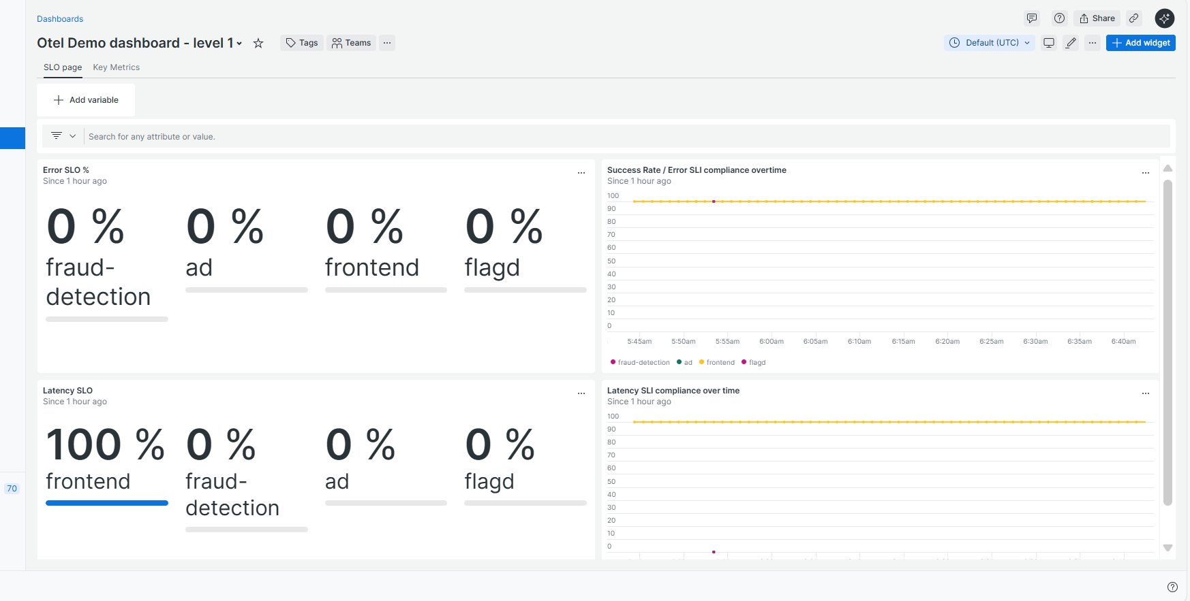

* When I select a particular service on level 0 the level 1 looks like this:

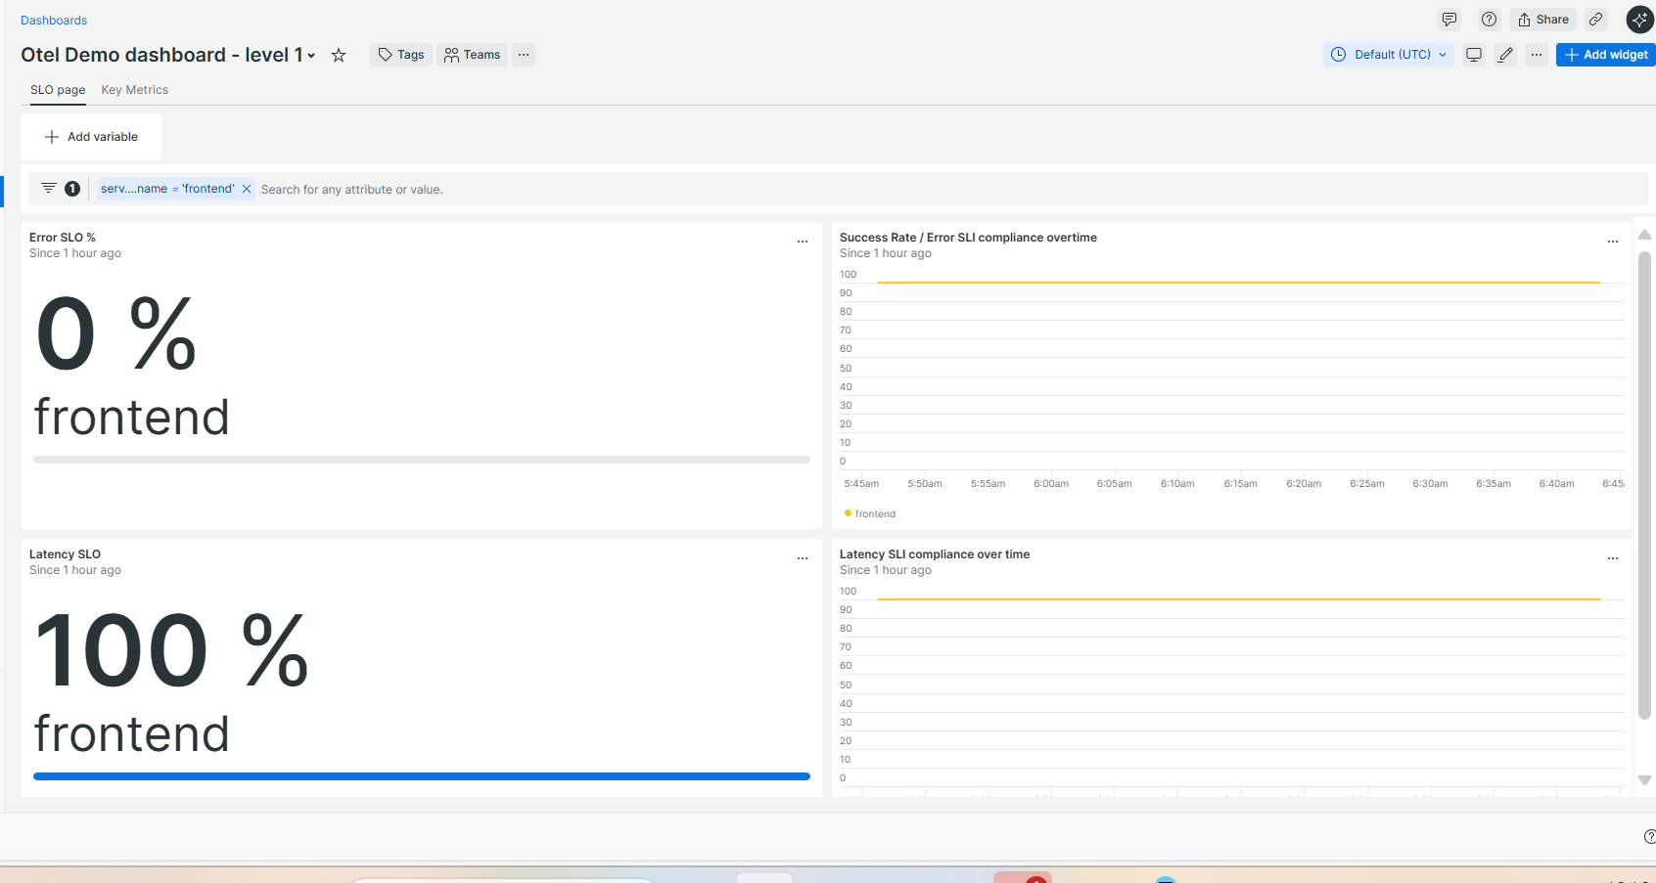

Q. Aim to create a level 2 dashboard similar to this:  
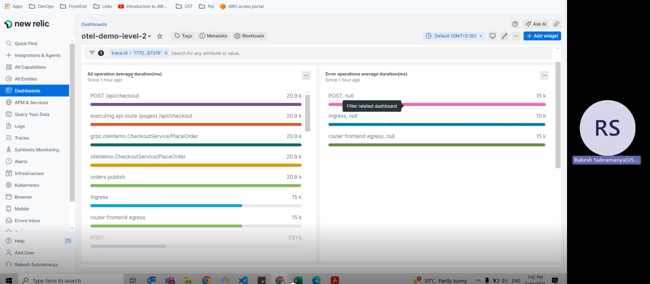

When I click on level 1 error per trace panel:

* When I click on each trace id it shows the details on level 2
* Panels required:
  + All operation average duration(ms)
  + Error operation average duration(ms)

1. Panel 1: All operation average duration(ms)

FROM Span

SELECT average(duration.ms)

FACET name

1. Panel 2: **Error Operation Average Duration (ms)** → Not possible because error spans lack both duration.ms and name
2. Panel 3: Error Rate by Trace ID

FROM Span

SELECT

filter(count(*), WHERE http.status_code >= 400) AS 'Error Spans',

count(*) AS 'Total Spans',

100 * filter(count(*), WHERE http.status_code >= 400) / count(*) AS 'Error Rate (%)'

FACET trace.id

1. Panel 4: Operation Duration Percentiles

FROM Span

SELECT percentile(duration.ms, 50, 95, 99)

FACET name

1. Panel 5: HTTP Method Breakdown

FROM Span

SELECT count(*)

FACET http.method

1. Panel 6: Trace Duration Summary

FROM Span

SELECT max(duration.ms), min(duration.ms), average(duration.ms)

1. Panel 7: Log for selected trace

FROM Log

SELECT count(*)

FACET timestamp, message

Screenshots:

* Also link level 1 with level 2 on error by trace panel.

Screenshots:

Level 0:

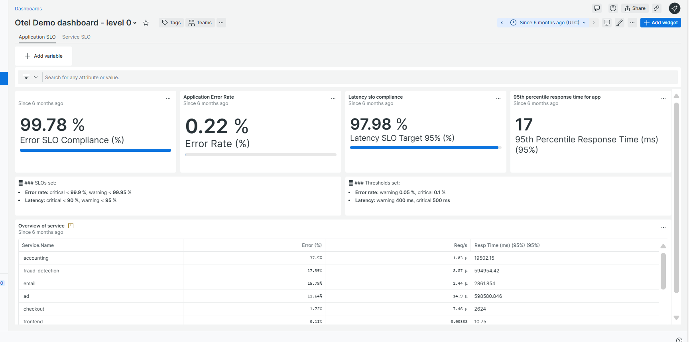

When I click on drill down panel:

Frontend:

Level 1:

Click the drill down panel:

Trace id:

Level 2:

Cryptowallet service level 2(logs can see)

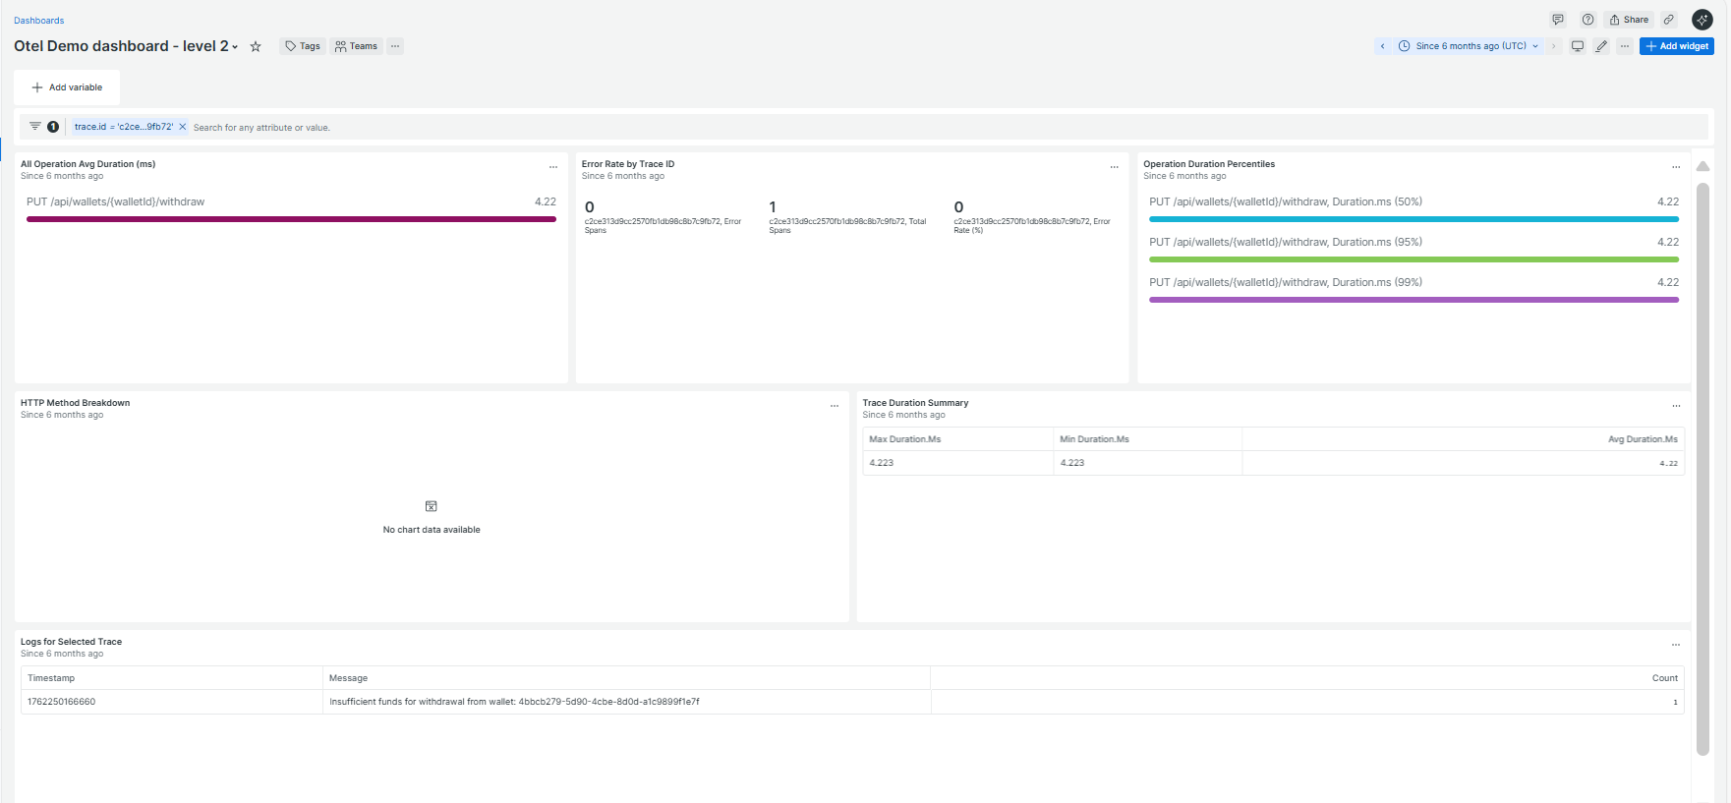

Only this service have logs.